Retail Discount Setups Dynamics AX

CASE 1: Apply 30% discounts on Product **100298**

For this kind of discounts navigate to **Retail > Common > price and discount > Discount**

Create a new discount by clicking **New**button

[1](http://thedynamicsblog.com/wp-content/uploads/2014/02/15.png)

Enter **discount** (normally auto generated from number sequence) and then enter name (if required)

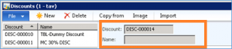

Enter all necessary information in **general fast tab** as below; select your price group from the drop down and currency in which discount is to be applied.

*\*Note: select the status as enabled when everything is finalized and hence it will not allow further editing.*

[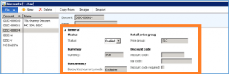](http://thedynamicsblog.com/wp-content/uploads/2014/02/33.png)

Enter**discount percentage** (e.g: 30%) which is required to apply on either single product or on a list of products. Then enter the **period in validation period** in which discount will be available.

[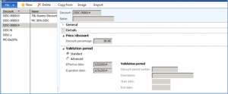](http://thedynamicsblog.com/wp-content/uploads/2014/02/42.png)

Select either a product (e.g: 100298 and 100299) or whole category in **Lines fast tab**.

[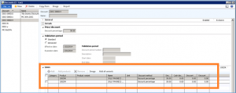](http://thedynamicsblog.com/wp-content/uploads/2014/02/52.png)

Enable the discount and Run job n-1020 for discounts.

Below is a sample transaction for this product on POS.

[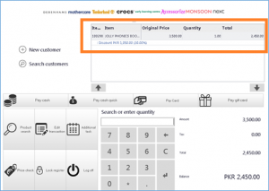](http://thedynamicsblog.com/wp-content/uploads/2014/02/61.png)

CASE 2: Apply buy one get on discounts same products

For this kind of discounts navigate to **Retail > Common > price and discount > Quantity Discount**

Create a new discount by clicking **New**button and add necessary information as below (screenshot)

[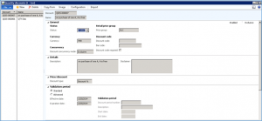](http://thedynamicsblog.com/wp-content/uploads/2014/02/01.png)

Select a product in **Lines fast tab**

[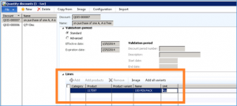](http://thedynamicsblog.com/wp-content/uploads/2014/02/02.png)

Click configuration (on top) to add minimums quantity to be offered as discount and enter discount % or discounted price for quantity.

[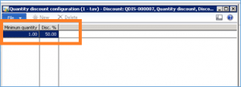](http://thedynamicsblog.com/wp-content/uploads/2014/02/03.png)

Enable the discount and Run job n-1020 for discounts.

CASE 3: Apply buy one get on discounts different products

For this kind of discounts navigate to **Retail > Common > price and discount > Mix and Match Discount**

Create a new discount by clicking **New**button and add necessary information as below (screenshot)

[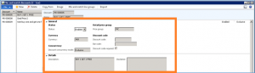](http://thedynamicsblog.com/wp-content/uploads/2014/02/112.png)

Select **line spec.**in price/discount tab

[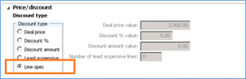](http://thedynamicsblog.com/wp-content/uploads/2014/02/122.png)

Enter a **validation period**of offer

After that in **Line fast tab**create two mix & match line discount by:

Line 1. For the item that sells for free (e.g: 100301). Set ‘Deal price’ to 0 for this line

Line 2. For the item that sells for full price (e.g: 100300). Set ‘Discount %’ to 0 for this line

[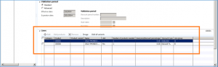](http://thedynamicsblog.com/wp-content/uploads/2014/02/131.png)

Select line group from drop down it will be catered from **Mix and match line group**(on top)

[14](http://thedynamicsblog.com/wp-content/uploads/2014/02/141.png)

Select a **line group** for each item

[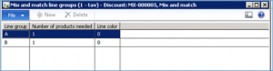](http://thedynamicsblog.com/wp-content/uploads/2014/02/151.png)

Enable the discount and Run job n-1020 for discounts.

A sample transaction is performed on POS using this discount.

[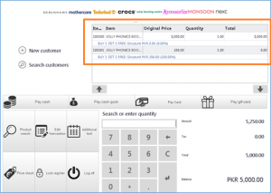](http://thedynamicsblog.com/wp-content/uploads/2014/02/16.png)